**Deposits and Endorsement Worksheets**

1. **Ardys Johnson had a rummage sale. She went to the bank today and deposited a $40.00 check (number 1245), a $85.00 check (#2789), and deposited $372.50 in cash. Complete the form below for Ardys.**

1. **Both checks deposited should be endorsed with a blank endorsement Complete the endorsements below for Ardys.**



1. **Ardys Johnson went to the bank on October 1, 2020. She deposited a check for $62.25 (#2345), a check for $79.56 (#3847), and a check for $704.96 (#4567). She withdrew $150.00 in cash. Complete the form below for Ardys.**

Ardys Johnson

Phone: 701-746-5555

4567 West 17th Ave

Grand Forks, ND 58201

Date: 20

Sign here for less cash in Teller’s presence

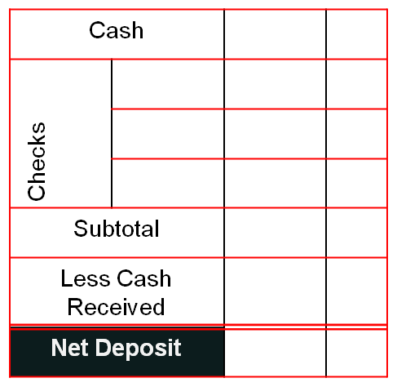

Dollars

1. **All three checks deposited should be endorsed with a restrictive endorsement to Sky Central Bank into account #812452014. Complete the endorsements below for Ardys on just one of the checks to show how a restrictive endorsement is written.**



1. **You receive a check for $250 for selling your bike. You use online banking for a mobile deposit. Write an endorsement for a mobile deposit.**



1. **You are Ardys, write A Check for today to Harley’s gas station for $36.52 for gas. Be sure to enter a memo that details what you purchased on the check.**
2. **What is the Bank Routing Number?**
3. **What is your Bank Account Number?**



07856784038568123445678918

8123445678918